LAB 4

DISK ENCRYPTION USING VERACRYPT, BITLOCKER AND ROHOS

TASK 1 : USING VERACRYPT :

1: Created my volume in veracrypt (in windows 11 vm )and opening a file and mounting it in drive. It usesd AES algorithm and Hashing for encryption. The drive is password protected:

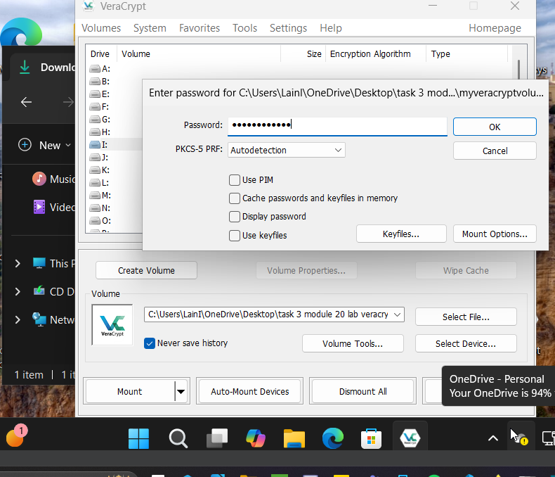

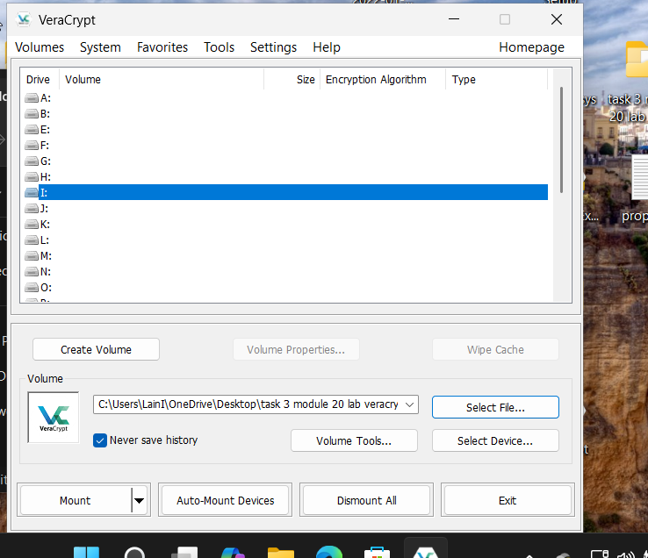



2: Writing a test document and uploading it to the drive. Click dismount to hide and encrypt the file in drive I. This can be only accessed by the people with the password to access:

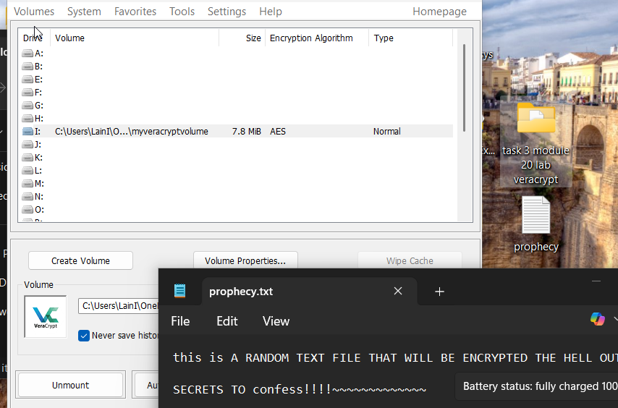

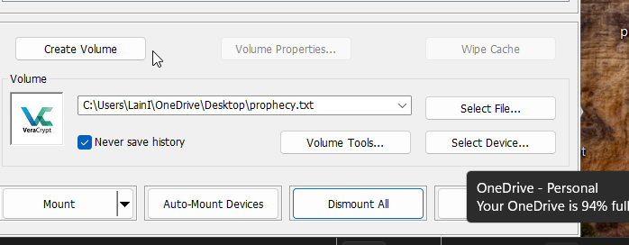

TASK 2 : Bitlocker Disk Encryption

1: Partition a new disk as new volume E to use in Bitlocker and making it password protected:

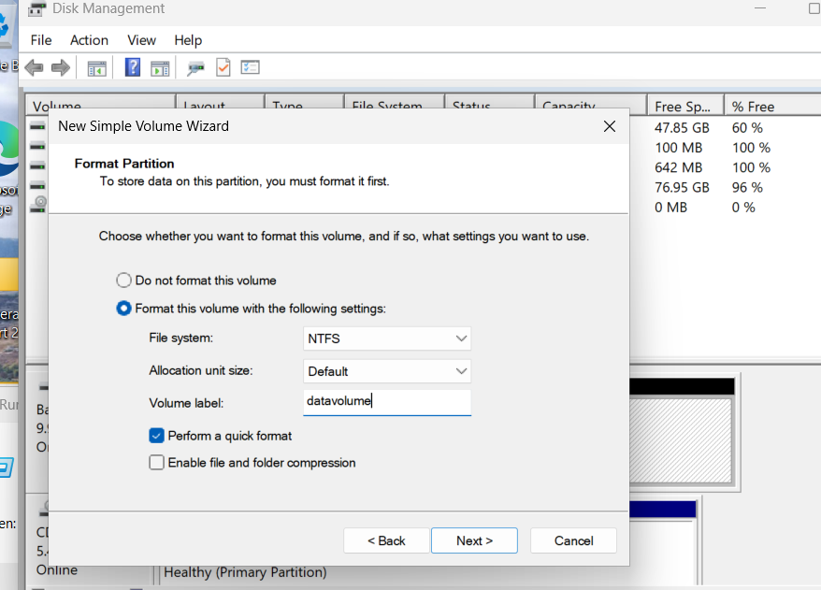

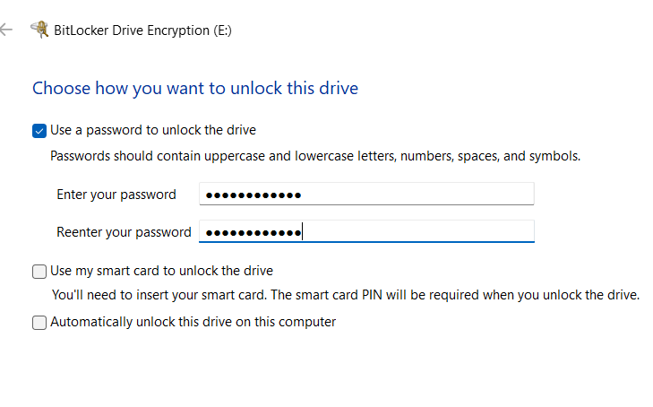

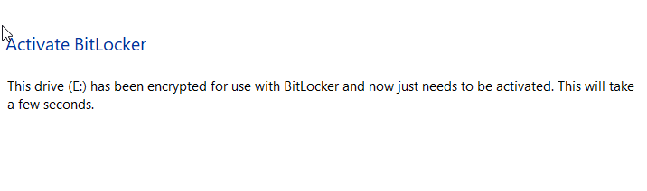

3: Disk E has been successfully encrypted and is protected with a password to access:

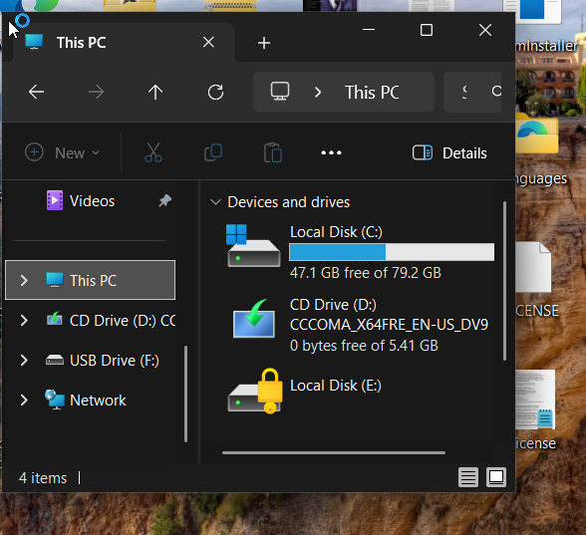

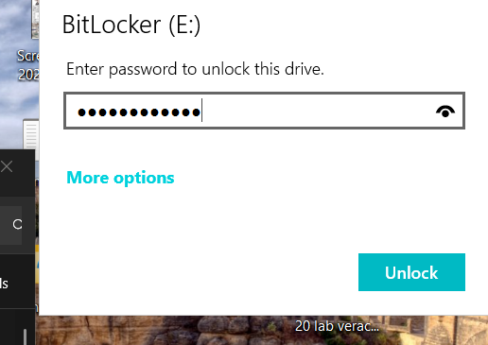

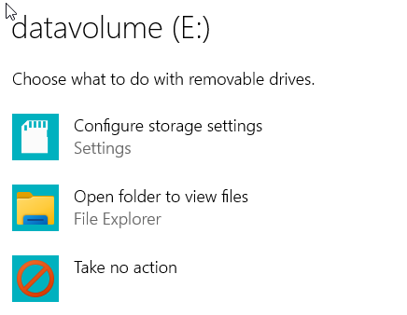

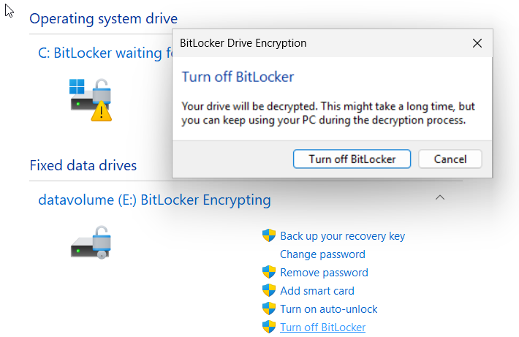

TASK 3 Rohos Disk Encryption

1: Opening up Rohos and creating a new disk volume to encrypt:

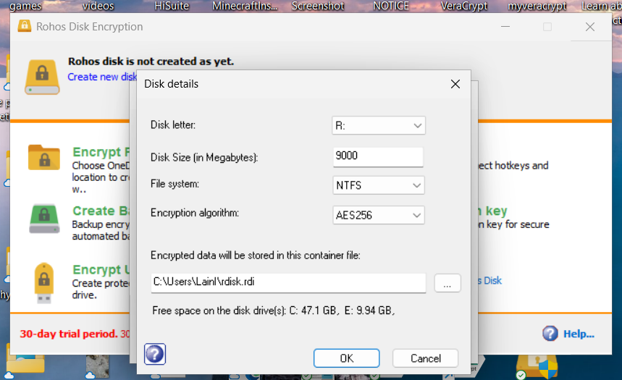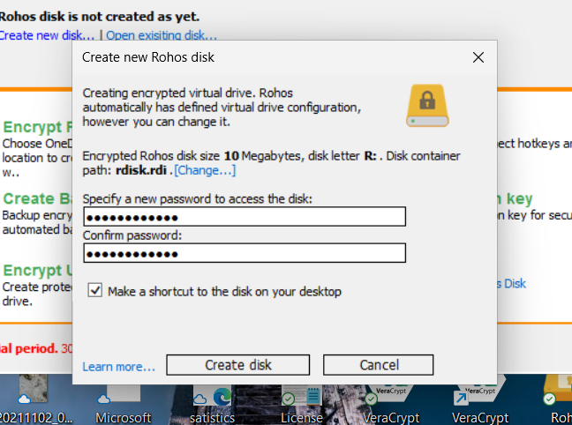

2: Test document created and stored in encrypted disk:

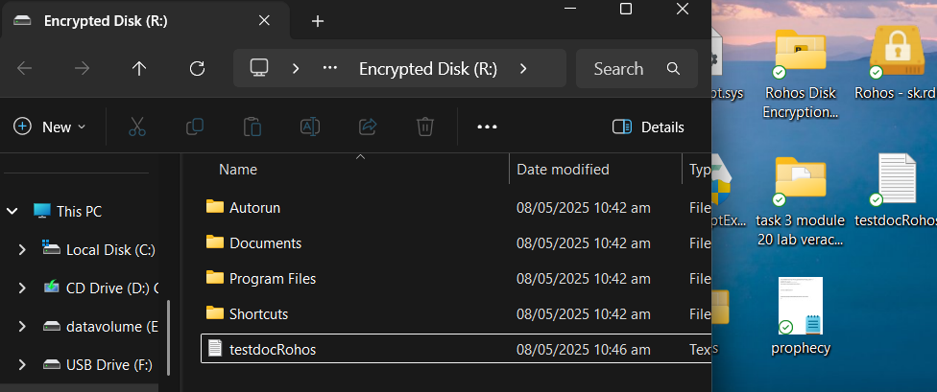

3: Closed the disk and tired to access it again. The disk now is now storing the file and only users with password can access.

